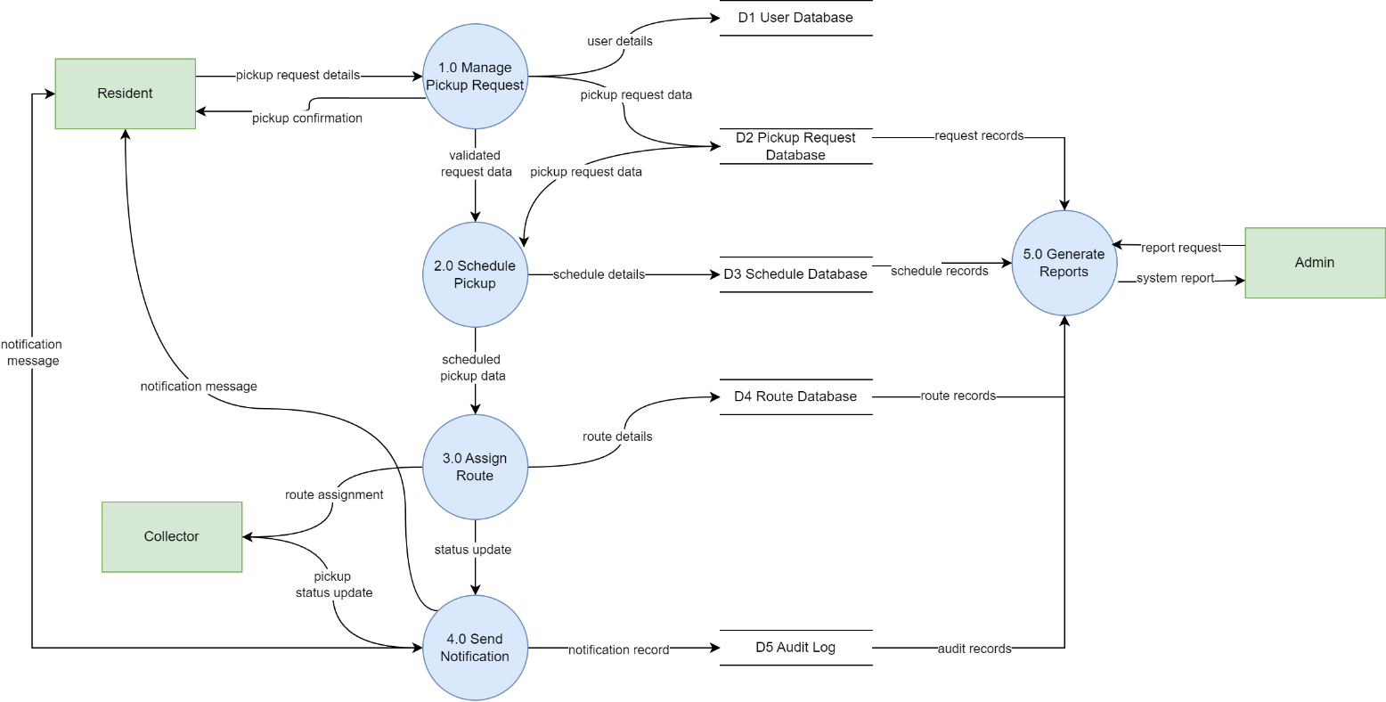
Recycling Pickup Scheduler DFD Level 0
The DFD Level 0 illustrates how the Recycling Pickup Scheduler System operates by breaking the system into five main processes and showing how data flows between external entities, processes, and data stores.
The system interacts with three external entities: Resident, Collector, and Admin. The resident submits pickup request details to the system and receives confirmation and notification messages. The collector receives route assignments from the system and sends back pickup status updates. The admin interacts with the system by requesting and receiving system reports.
The system is divided into five main processes. The Manage Pickup Request process handles user requests and stores them in the pickup request database. The Schedule Pickup process assigns appropriate time slots and stores scheduling information. The Assign Route process allocates routes to collectors based on the schedule. The Send Notification process informs users about updates such as confirmation, scheduling, and completion. Finally, the Generate Reports process allows the admin to access system data and generate reports.
All important data is stored in data stores, including the user database, pickup request database, schedule database, route database, and audit log. These data stores ensure that information can be reused for processing and reporting.
Overall, the diagram shows how user requests are processed step by step into scheduled pickups, assigned routes, and notifications, while maintaining data within the system for future use.

